主标题: handheld rfid reader
副标题：HT550 android uhf rfid handheld reader
Key features:
8-core 2.0GHz, Android 13 operating system
5.5-inch screen
UHF RFID: Reading distance 1-15 meters (tag and environment related)
Barcode, QR code scanning
4G communication, dual band Wi Fi, and Bluetooth for seamless connectivity

handheld rfid reader-1
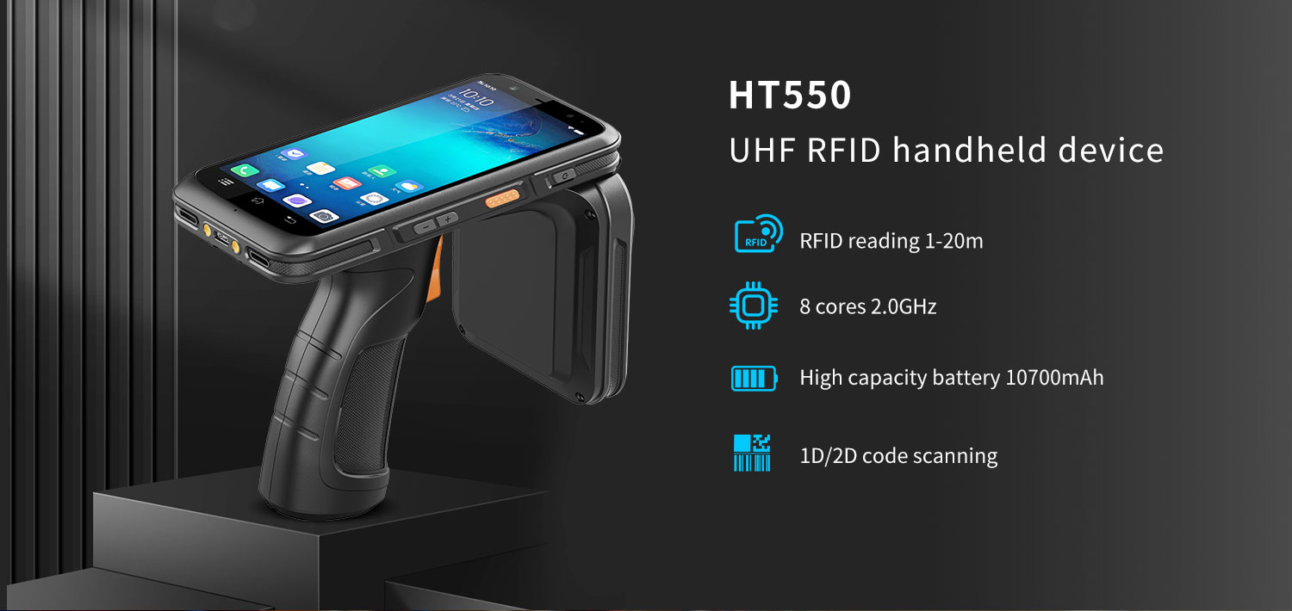
- The HT550 android pda rfid reader is equipped with a powerful eight core MediaTek MT6762 CPU, with each core running at a maximum frequency of 2.0GHz, ensuring fast task processing. Android 13 operating system. In addition, it is equipped with 3GB RAM and 32GB internal storage space, allowing for smooth switching between 15-20 active applications.
- HT550 handheld rfid reader with built-in Impinj E710 chip ultra-high frequency RFID module, readable and writable, RFID tag reading distance of 1-15 meters. Excellent group reading performance, reading 200 RFID tags per second.
- [Optional Scanning Function]: The HT550 Android handheld RFID tag reader supports the optional TMS-E60 scan head, which can quickly identify barcodes and QR codes.
- The HT550 RFID handheld terminal has an IP67 protection level and is dustproof and splash proof. It also supports a 1.2-meter drop resistance, making it durable even in harsh environments such as warehouses or logistics operations.
handheld rfid reader-2
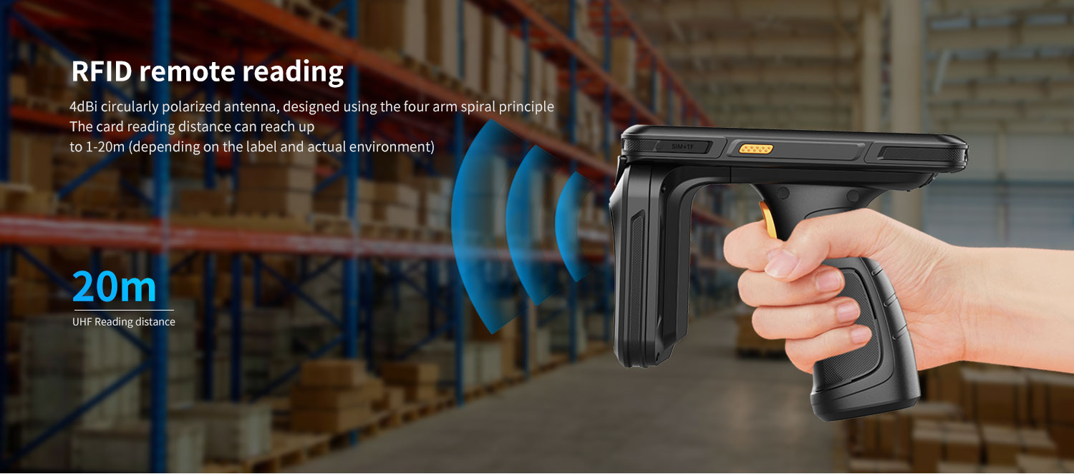
HT550 handheld rfid reader with built-in Impinj E710 chip ultra-high frequency RFID module
Readable and writable, distance 1-20 meters
Operating frequency (860-960 MHz, frequency band can be customized according to requirements)
Chinese frequency: 920-925 MHz
US frequency: 902-928 MHz
Other frequencies: Other multinational frequency standards (customized)
Protocol standards: EPC C1 GEN2/ISO18000-6C, GJB7377.1A-2018 (optional)
Antenna: 4dBi circularly polarized antenna, designed using the four arm spiral principle
Reading distance: 1-20M (depending on the label and actual environment)
Group reading speed: 2000+tags/10 seconds
handheld rfid reader-3

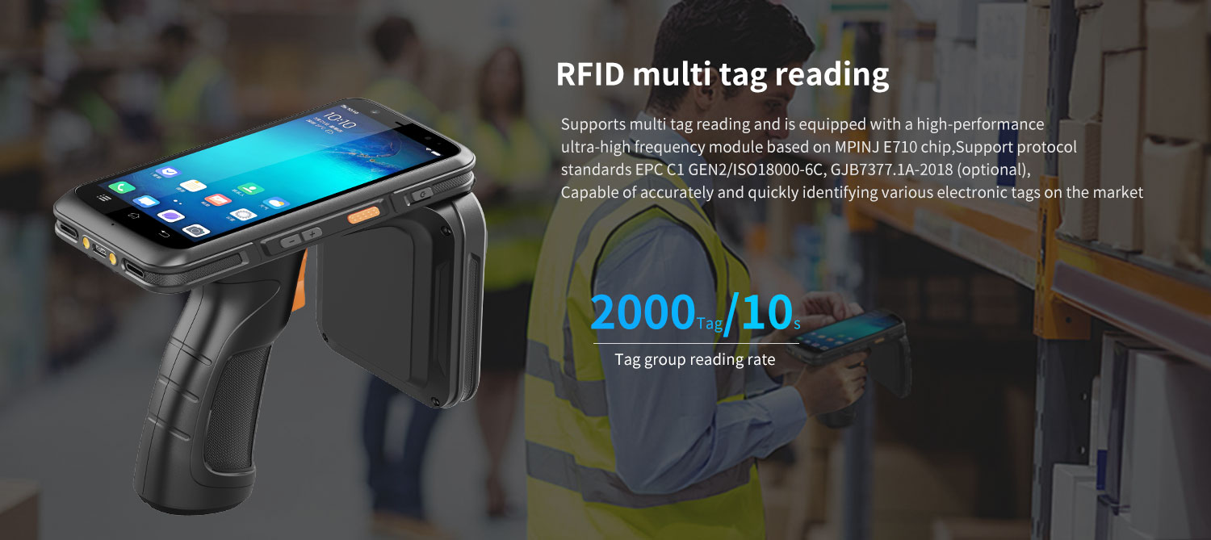
handheld rfid reader-4
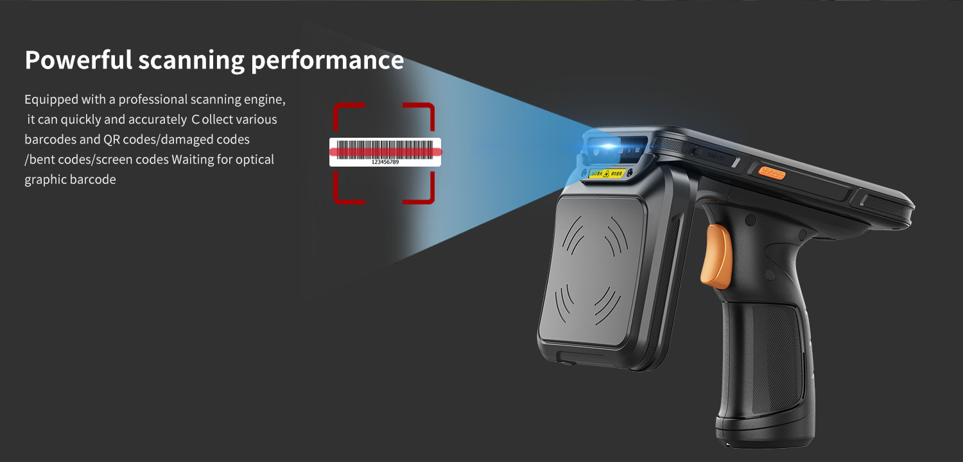
scanning engine - optional
The HT550 handheld rfid reader optional TMS-E60 scanning engine, with high brightness LED providing exposure assisted lighting, allowing for quick barcode recognition even in completely dark conditions. TMS-E60 provides laser aiming indicator patterns to assist users in aiming at targets, facilitate barcode recognition, and improve recognition efficiency. Capable of reading the most commonly used barcodes in the retail, logistics, and healthcare industries, such as Code 11, Code 128, PDF417, EAN codes, etc. It even supports scanning damaged barcodes and screen barcodes.

handheld rfid reader-5
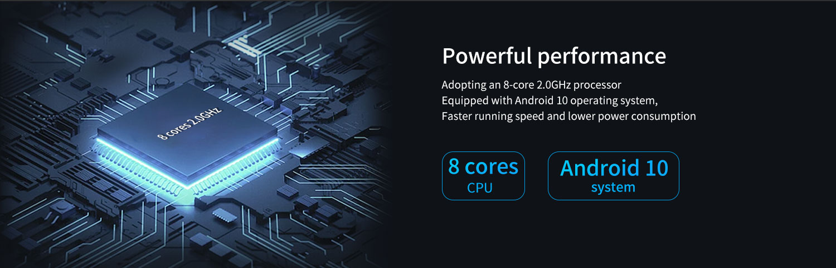
High performance CPU
MT6762 CPU: Experience the powerful performance of MediaTek MT6762, designed specifically for seamless multitasking on your PDA device.
Standard memory 3G+32G, optional 4GB+64GB: Provides ample storage space for all your applications and files with a high memory configuration.
handheld rfid reader-6
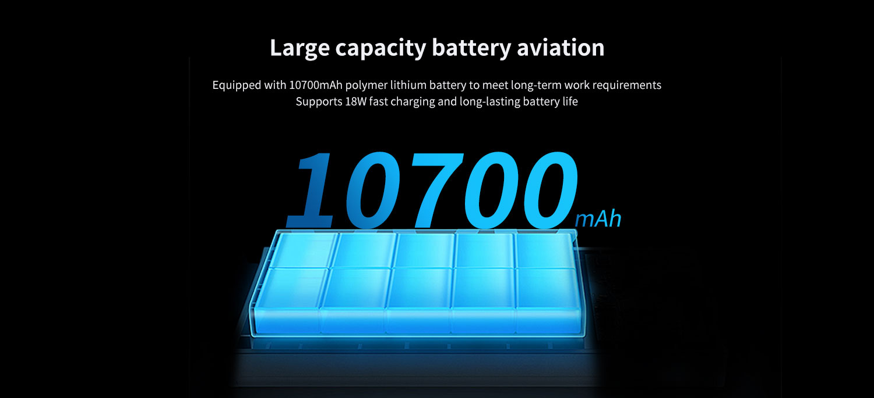
Large capacity battery, long endurance.

handheld rfid reader-7
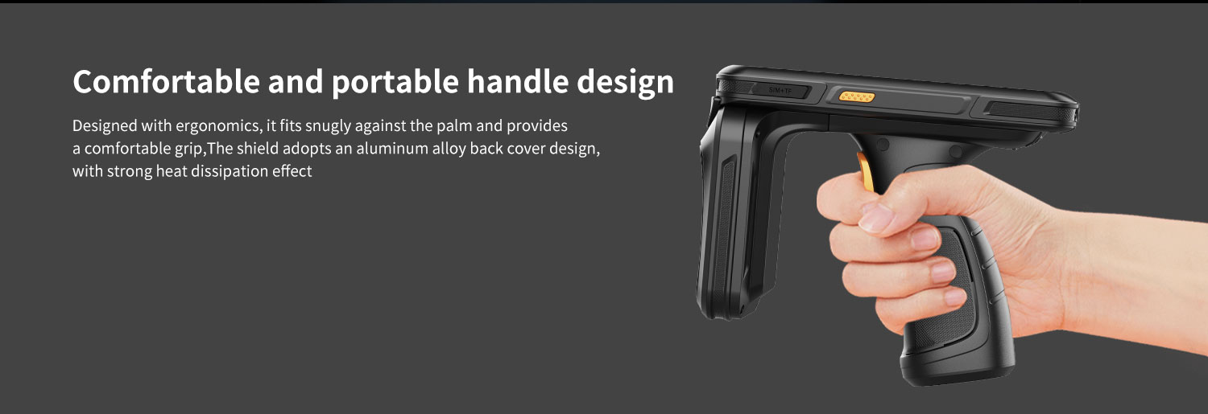
The HT550 portable RFID tag reader is equipped with a 5.5-inch touch screen, which allows for normal keyboard operation even when hands are wet or gloves are worn, making it more widely applicable.
handheld rfid reader-8
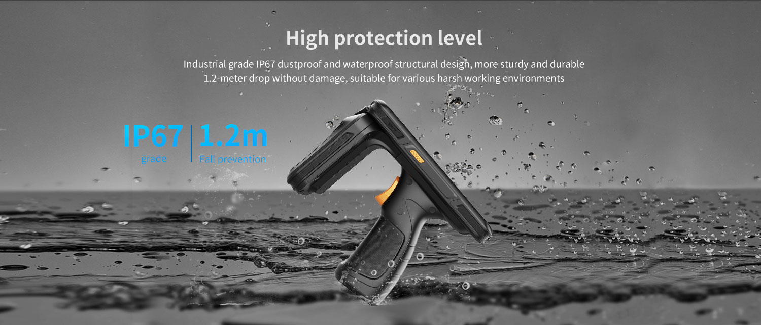
IP67 protection level
1.Dustproof: Fully enclosed design to prevent dust from entering and ensure the safety of internal components.
2.Waterproof: This HT550 Android handheld mobile RFID reader has splash proof function, but should not be immersed in water.

handheld rfid reader-9
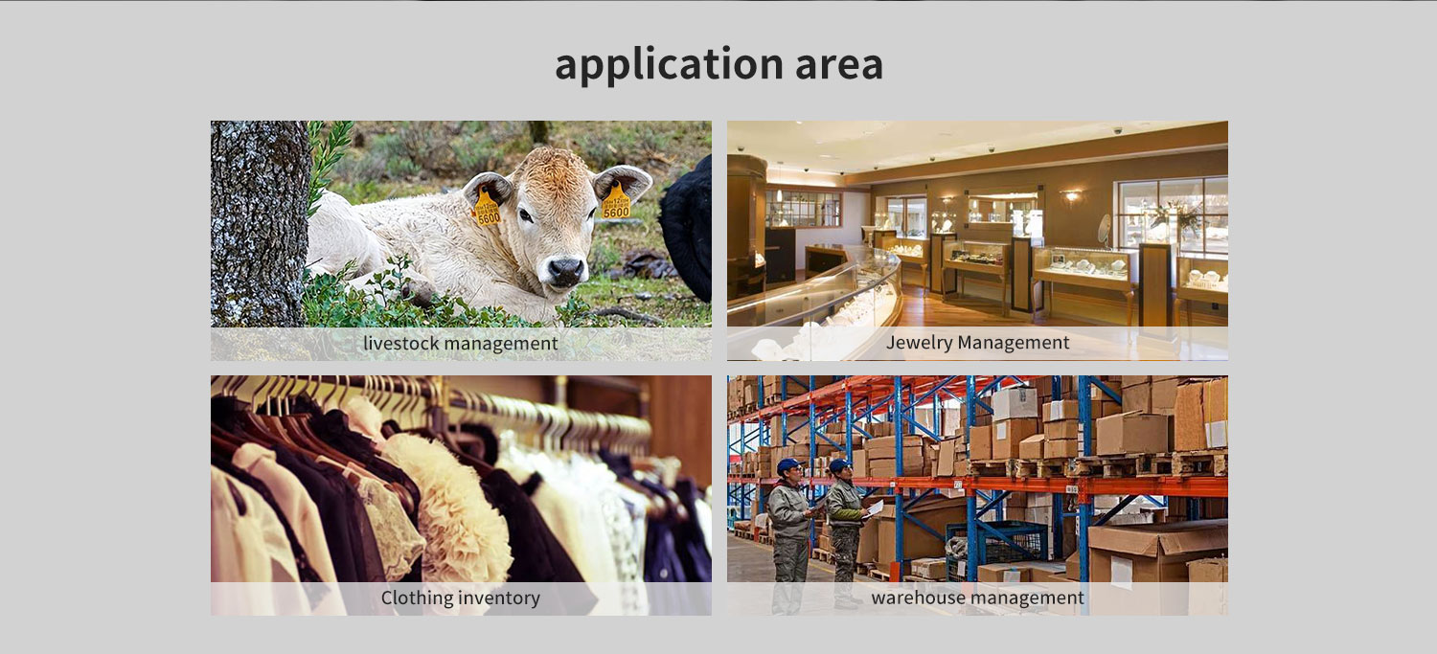
handheld rfid reader-10

Provide ODM and OEM customized services
We work closely with our partners and can provide various one-stop customized solutions.
Appearance customization: supports customization of product nameplates, product packaging, and promotional materials.
Hardware customization: Supports customization of functional modules and optional hardware functions.
Software customization: supports customization of boot interface, boot program, kernel clipping, and API interface.
Technical support: Provide SDK development kits and application software development technical services.

HARDWARE CUSTOMIZATION
1: Nameplate Logo Customization
2:Packaging Custom Design
﻿
SOFTWARE CUSTOMIZATION
1:Boot Screen Customization
2:System Function Hiding
3:Built-in Customer App
4:Customer App Auto-launch
5:Platform Software Integration
6:Fixed MAC Address
7:Download Prohibition
﻿8:USB Disablement
﻿9:APP Installation and Uninstallation Control
10:Pre-installed APK
﻿11:Camera Control
12:Provide System Signing Files

frequently asked questions
Q: Are you the original manufacturer?

A: Yes, we are the original manufacturer. We have our own brand LQYCIT. All of our products have complete patented ID/MD designs, hardware and software, molds, and assembly are all completed by our own team.

Q: Can you pre install our software?

A: Yes, we can pre install your software.

Q: What is the minimum order quantity?

A: We accept standard product orders starting from one unit. If necessary, we can even customize your logo. For OEM, our sales team will review the detailed requirements and confirm the minimum order quantity.

Q: Can we get free samples?

A: Sorry, we usually do not provide free samples. If the customer confirms the specifications and pricing, they can first order samples for testing and evaluation.

Q: How to place an order and make payment?

A: We accept wire transfers (bank transfers), Alibaba online payments, and Western Union remittances.

Q: What is the warranty period for your products?

A: We offer a 12-month warranty after shipment.

Q: How long is the delivery time?

A: The production delivery cycle is about 3-10 days, depending on the requirements. The delivery time through DHL/UPS/FedEx/TNT is approximately 3-5 working days. For some remote areas, the transportation time may be longer.

Q: How to fix equipment problems?

A: We will provide online technical support to solve problems. For hardware issues, we can ship parts or components for customers to install (if they have technicians), or we can ship them back to us for repairs.

